**GOVERNMENT POLYTECHNIC**

**NAGPUR**

**DEPARTMENT OF INFORMATION TECHNOLOGY**



**INTERNSHIP REPORT**

**SESSION 2020-2021**



**Technical Head: Presented By:**

Mr. Sachin Matta Dipanshu Sendre



**Department of Information Technology**

**Government Polytechnic, Nagpur**

An Autonomous Institute of Government of Maharashtra

Sadar, Nagpur 440 001(M.S.)

CERTIFICATE

This is to certify that the Internship Report entitled

Industrial Training in Computer Networks

submitted by

**Dipanshu Sendre**

is a bonafide work carried out by him under the supervision of **Mr. S.J. Pukale** and it is submitted towards the partial fulfilment of the requirement of Government Polytechnic, Nagpur for the award of Diploma in Information Technology.

|  |  |
| --- | --- |
| **Mr. S.J. Pukale** | **Dr. A.R. Mahajan** |
| Lecturer | HOD |
| Department of Information Technology | Department of Information Technology |
|  |  |

Place: Government Polytechnic, Nagpur

Date: February 17, 2021

**DECLARATION**

During my internship in Sam Computer Services Pvt. Ltd and preparation of this report I realized that it is the joint venture guidance, assistance and co-operation. So, it would have not been completed without and declaration and help received. It is matter of great privileges to express my deep sense of gratitude towards my guide Mr. Sachin Matta at Sam Computer Services Pvt. Ltd Nagpur. For having his guidance, I am extremely thankful to him for constant motivation and inspiration extended throughout during internship work which has made me possible to complete the work in scheduled time. My sincere thanks to all the faculties.

**Submitted By:**

Dipanshu Sendre

**ACKNOWLEDGEMENT**

I have taken efforts in the project. However, it would not have been possible without the kind and help of support and help of many individual and organizations would like to extend my sincere thanks to all of them.

I am highly indebted to Mr. Sachin Matta for their guidance and constant supervision as well as for providing necessary information regarding the project &also for their support in completing the project. I would like to express my gratitude toward my parents & members of Sam Computer Services Pvt. Ltd. for their kind cooperation and encouragement which help me in completion of this project.

I would like to give my special gratitude and thanks to industry persons for giving me such attention and time.

My thanks and appreciation also go to my colleague in developing the project and people who have willingly helped me out with their abilities.

**Technical Head Presented By:**

Mr. Sachin Matta Dipanshu Sendre

INDEX

**Topics Page No.**

Chapter 1: Introduction to Computer Networks 7

Chapter 2: Types of Networking 8

Chapter 3: Models of Networking 10

Chapter 4: Types of Computer Networks 12

Chapter 5: Basic Hardware Components 15

Chapter 6: Designing an Ethernet Network 19

Chapter 7: References 22

**List of Figures**

**Figures Page No.**

1. Computer Network 7
2. Wired Networks 8
3. Wireless Networks 9
4. Client-Server Model 10
5. Peer to Peer Model 11
6. Network Interface Card 15
7. Repeaters 16
8. Hubs 16
9. Bridges 17
10. Switches 17
11. Routers 18

**Chapter 1**

**Introduction to Computer Networks**

A computer network is a group of computers that are interconnected by electronic circuits or wireless transmissions of various designs and technologies for the purpose of exchanging data or communicating information between them or their users. Networks may be classified according to a wide variety of characteristics. This article provides a general overview of types and categories and also presents the basic components of a network.

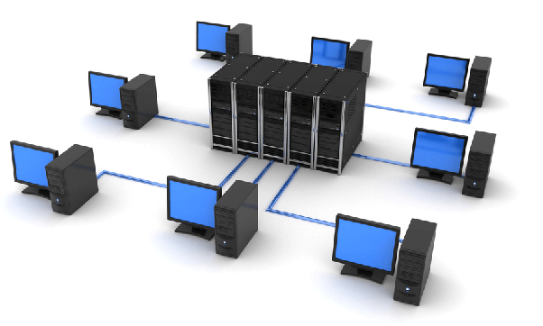

Fig No.1: Computer Network

A computer network allows sharing of resources and information among devices connected to the network. In a network environment, any authorized computer user can access data and information stored on other computer on the network. The capability of providing access to and storage of data and information on shared storage devices is an important feature of many networks.

**Chapter 2**

**Types of Networking**

There are Two Types of Networking:

* Wired Networks
* Wireless Networks

**Wired Networks:**

Wired networks are almost always faster and less expensive that wireless networks. Once connected, there is little that can disrupt a good-wired connection. Wired networks come in many forms, but the most popular are HomePNA and Ethernet. HomePNA uses the existing phone line wires in your home and Ethernet needs special network cabling.

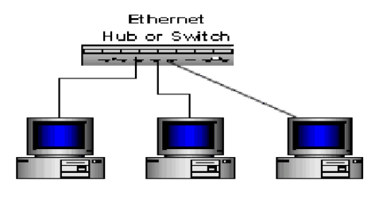

Fig No.2: Wired Networks

**Wireless Networks:**

Computer networks that are not connected by cables are called wireless networks. They generally use radio waves for communication between the network nodes. They allow devices to be connected to the network while roaming around within the network coverage.

Examples of Wireless Networks:

1. Mobile Phone Networks
2. Wireless sensor Networks
3. Satellite Communication Networks

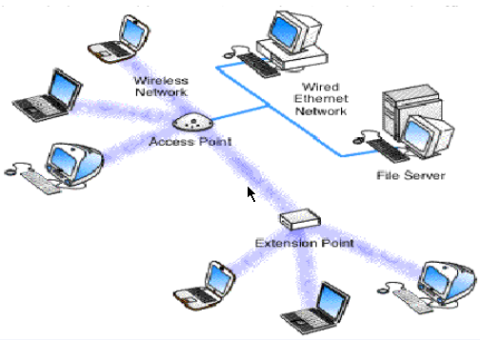

Fig No.3: Wireless Networks

**Chapter 3**

**Models of Networking**

Models means the connectivity of two computers. We have many types of networking models.

* Client-Server Model
* Peer to Peer Model
* Domain Model

**Client-Server Model**

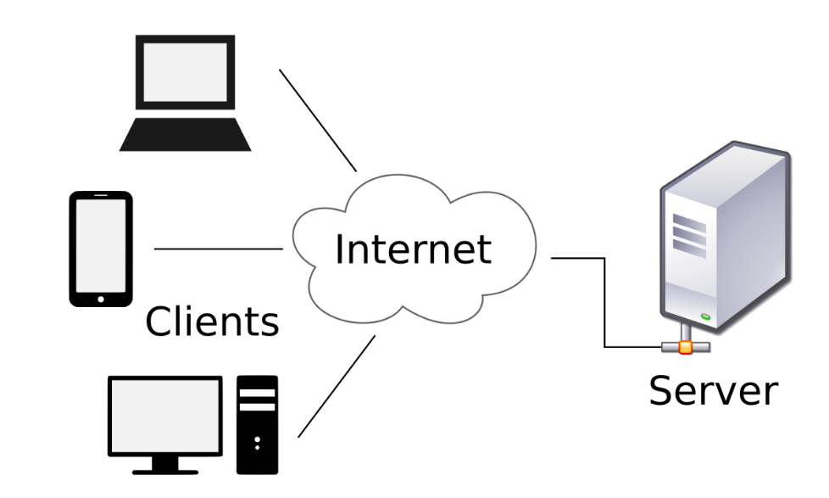

Fig No.4: Client-Server Model

In Client-Server Model, we have one server and many clients. A Client can share the resources of server, but a server cannot share the resources on clients.

On the point of view of administrator, its very easy to control the network because we combine with the server also at security point of view. It is very useful because it uses user level security in which user have to remember only one password to share the resources.

**Peer to Peer Model**

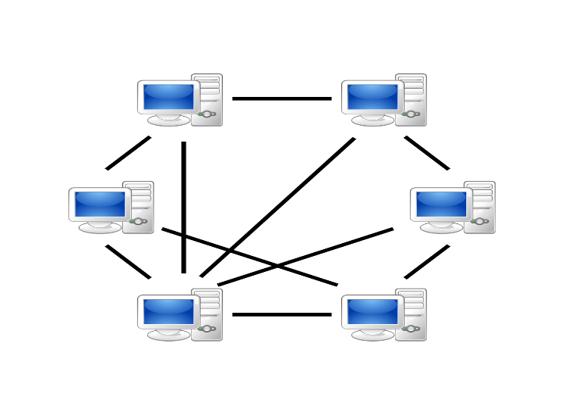

Fig No.5: Peer to Peer Model

In Peer-to-Peer networking model all the computers are in equal status, that is we cannot manage centralization, administration security. In Peer-to-Peer networking client use operating system like Window 98, Window XP, Window 2000, Window Vista.

**Domain Model**

It is a mixture of client server and peer to peer model. In this client can share their resources as peer to peer but with the permission of the server as in client server model therefore it is commonly used model because in this security is more as we can put restriction on both server and clients.

**Chapter 4**

**Types of Computer Networks**

Common types of computer networks may be identified by their scale.

**Personal Area Network**

A personal area network (PAN) is a computer network used for communication among computer devices close to one person. Some examples of devices that are used in a PAN are personal computers, printers, fax machines, telephones, PDAs, scanners, and even video game consoles. A PAN may include wired and wireless connections between devices. The reach of a PAN typically extends to about 30 feet (approximately 9 meters).

A wireless personal area network in which the connections are wireless. IEEE 802.15 has produced standard for several types of PANs operating in the ISM band including Bluetooth.

**Local Area Network**

A local area network (LAN) is a network that connects computers and devices in a limited geographical area such as home, school, computer laboratory, office building, or closely positioned group of buildings. Each computer or device on the network is a node. Current wired LANs are most likely to be based on Ethernet technology, although new standards like ITU-T G.hn also provide a way to create a wired LAN using existing home wires (coaxial cables, phone lines and power lines)

Current Ethernet or other IEEE 802.3 LAN technologies operate at speeds up to 10 Gbit/s. This is the data transfer rate.

**Metropolitan Area Network**

A metropolitan area network (MAN) is a network that connects two or more local area networks or campus area networks together but does not extend beyond the boundaries of the immediate town/city. Routers, switches and hubs are connected to create a metropolitan area network.

Metropolitan Area Network is designed for the customers who need a high-speed connectivity. Speed of MAN ranges in terms of Mbps. Its hard to design and maintain a Metropolitan Area Network.

**Wide Area Network**

A wide area network (WAN) is a computer network that covers a large geographic area such as a city, country, or spans even intercontinental distances, using a communications channel that combines many types of media such as telephone lines, cables, and air waves. A WAN often uses transmission facilities provided by common carriers, such as telephone companies. WAN technologies generally function at the lower three layers of the OSI reference model: the physical layer, the data link layer, and the network layer.

There are two types of Wide Area Networks: Switched WAN and Point-to-Point WAN. WAN is difficult to design and maintain, similar to a MAN. MAN’s data rate is slow about a 10th LAN’s speed (kbps to Mbps), since it involves increases in distances and increases in number of servers and terminals.

**Global Area Network**

A global area network (GAN) is a model for supporting mobile communications across an arbitrary number of wireless LANs, satellite coverage areas, etc. The key challenge in mobile communications is handing off the user communications from one local coverage area to the next. In IEEE Project 802, this involves a succession of terrestrial WIRELESS local area networks (WLAN).

**Virtual Private Network**

A global area network (GAN) is a model for supporting mobile communications across an arbitrary number of wireless LANs, satellite coverage areas, etc. The key challenge in mobile communications is handing off the user communications from one local coverage area to the next. In IEEE Project 802, this involves a succession of terrestrial WIRELESS local area networks (WLAN).

A Virtual Private Network (VPN) is a network that provides the mobile user with a secure connection to the company network server, as if the user had a private line. A VPN allows computer users to appear to be editing from an IP address location other than the one which connects the actual computer to the Internet.

**Chapter 5**

**Basic Hardware Components**

All networks are made up of basic hardware building blocks to interconnect network nodes, such as Network Interface Cards (NICs), Bridges, Hubs, Switches, and Routers.

**Network Interface Cards**

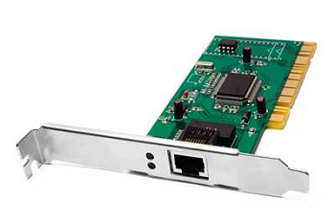

Fig No.6: Network Interface Card

A network card, network adapter, or NIC (network interface card) is a piece of computer hardware designed to allow computers to communicate over a computer network. It provides physical access to a networking medium and often provides a low-level addressing system through the use of MAC addresses.

Network Cars are of two types:

1. Internal Network Cards
2. External Network Cards

**Repeaters**

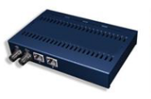

Fig No.7: Repeaters

A repeater is an electronic device that receives a signal, clean it from the unnecessary noise, regenerate it and retransmits it at a higher power level, or to the other side of an obstruction, so that the signal can cover longer distances without degradation. In most twisted pair Ethernet configurations, repeaters are required for cable which runs longer than 100 meters.

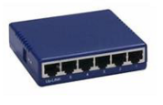**Hubs**

Fig No.8: Hubs

A network hub contains multiple ports. When a packet arrives at one port, it is copied unmodified to all ports of the hub for transmission. The destination address in the frame is not changed to a broadcast address.

**Bridges**

A network bridge connects multiple network segments at the data link layer (layer 2) of the OSI model. Bridges do not promiscuously copy traffic to all ports, as hubs do, but learn which MAC addresses are reachable through specific ports. Once the bridge associates a port and an address, it will send traffic for that address only to that port. Bridges do send broadcasts to all ports except the one on which the broadcast was received.

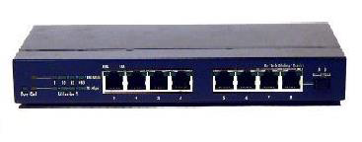

Fig No.9: Bridges

Bridges come in three basic types:

• Local bridges

• Remote bridges

• Wireless bridges

**Switches**

A network switch is a device that forwards and filters OSI layer 2 datagrams between ports based on the MAC addresses in the packets. This is distinct from a hub in that it only forwards the frames to the ports involved in the communication.

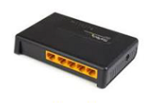

Fig No.10: Switches

Switches make forwarding decisions of frames on the basis of MAC addresses. A switch normally has numerous ports, facilitating a star topology for devices, and cascading additional switches. Some switches are capable of routing based on Layer 3 addressing or additional logical levels; these are called multi-layer switches.

**Routers**

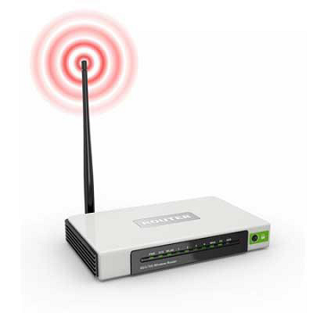

Fig No.11: Routers

A router is a networking device that forwards packets between networks using information in protocol headers and forwarding tables to determine the best next router for each packet. Routers work at the Network Layer (layer 3) of the OSI model and the Internet Layer of TCP/IP.

**Chapter 6**

**Designing an Ethernet Network**

In this chapter, we are going to design an Ethernet network for our collage. We are going to implement all the necessary requirements and possible solution which will helps us to design the network.

**We have to consider following requirements firstly:**

* Types of Networks.
* Main Access Point.
* Types of Network Media.
* Types of protocols to be used as per application
* Types of Security features to be added.
* No. of Users to access Internet Traffic.

**Here we have the following specified requirements, which is required in our collage network.**

* There is main 13 departmental buildings in the campus.
* Each and every department should be connected with everyone.
* Everyone should able to access central resources.
* Every router should be connected with fiber links.
* Corporate house can able to access internet 24*7.
* Also, outsider can’t destroy or damage the internal network and data.

**Implementation:**

Here we are going to start designing the network after discussing all the requirements.

* We have provided to use 13 departmental buildings, SO we are supposed to use 13 routers because all the 13 departments are physically separated.
* Now all the 13 routers are well separated from each other so we are supposed to use fiber links rather than serial link to connect the routers.
* Also, all the departments are connected in a ring topology so if one of the links breaks than also the communication between all the departments can be possible.
* Corporate Offices are directly connected to the networking department o that client from corporate office can access the internet 24*7 and all the data with higher speed and easily.
* Other departments like Mechanical, Civil, Electrical, Automobile, Metallurgy and Textile Engineering are not provided all time internet facility, they are provided their time slots in which they can access internet and this feature enhances between unitizations.
* We have used Network Adress Translation for the internet access for all the departments in the router from where campus is connected to the outside world.
* All the departments are connected with intranet so they can communicate through it.
* Also, Automobile and Textile departments is sharing the same building so their connection given from a single router.
* Also, we have created a VLAN in Automobile and Textile departments which will prevents the flow of data from vlan1 to vlan2 and vice-versa.

That’s how we have implemented all the requirements and policies to get proper working network between 13 departments in our collage.

**Chapter 7**

**References**

1. Computer network and communication by A. F. Hartung
2. A computer network monitoring system by David E. Morgan; Walter banks
3. [www.studumafia.org](http://www.studumafia.org)
4. [www.wikipedia.org](http://www.wikipedia.org)
5. [www.google.com](http://www.google.com)